Price List

Effective: May 21, 2021

Cremation Help by Dermody’s is an Online Simple Cremation Package offering by P. X. Dermody Funeral Home (1989) Limited which is licensed by the Bereavement Authority of Ontario as a Class 1 Funeral Establishment Operator (License FE-26) and operates as P. X. Dermody Funeral Home and Cremation Help.ca

Location Manager in charge of day to day operations:

7 East Avenue South, Hamilton ON Paul Dermody

Telephone: 905-512-5799 Web: www.cremationhelp.ca

Cremation Help

Cremation Help by Dermodys is proud to offer a new convenient online arrangement process and practical approach to arranging funeral and cremation services. You will never be asked to come in the office, instead, you will make the arrangements in the comfort of your own home.

We provide dignified care for the deceased, a cremation container and transportation from place of death to our facility and then to the crematorium. We register all documents with the Province, arrange for Coroner’s authorization for cremation, assist with CPP applications and give you proof of death certificates to settle the Estate. Once cremation has taken place, we return the cremated remains in a container.

Whether you’re looking for affordability or a personalized yet simpler tribute, we want you to know that we specialize in cremation. We are now able to offer the services you want at the best online price. We are here to serve your family in their time of need day or night.

This lower cost option still includes the respectful care and professional conduct you have come to expect from Dermodys. These two elements have no price tag associated with them. Instead they are part of our business beliefs and commitment to your family. Our goal is to create a far simpler, less expensive, and more convenient tribute to your loved one.

Professional Service Package
On-line arrangements only

Professional and Staff Services $300
Coordination of activities including transfer of remains,
arranging identification, casketing and transfer to crematorium

Documentation $200
Securing medical and legal authorizations, registration of death
And providing 10 Proof of Death certificates for the Estate

Transport Remains $235
Transport remains from the place of death and to the crematorium in
a secure vehicle within 50Kms each way. Over 50Kms at $2 per Km

Facilities for Shelter & Care $160
Facilities to shelter and care for the body, arrange identification of the body
and casketing of the body

Administrative Vehicle $175
Use of vehicle to register death, secure cremation and coroner’s certificate

Cremation Container $225
Eternite 101 Wood Tray (after package discount)

Above subject to taxes

Disbursements
Items paid on your behalf by the funeral home. Include taxes.

Registration of Death $48
Register with Hamilton City

Coroners Certificate $75
Coroners Certification of Death

Cremation Fee $560
Holy Cross Crematorium
Additional Fees (If required)
In person arrangements at 7 East Ave. S. $500
Still requires you to have an email address and internet access)

Pacemaker Removal $90
Oversize (300 lbs +) $400
(Includes additional cremation time & larger Eternite 101)
(Not all caskets are available in oversize)

Witness Cremation $245

Canada Post Delivery of Cremated Remains within Canada $90

Table of Caskets & Containers
# | PHOTO | CASKET NAME, MODEL # AND DESCRIPTION | $ PRICE
1 | 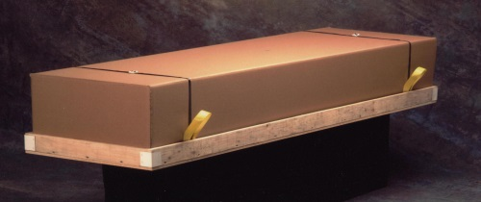 | Eternite 101 Wood Tray and Corrugated Top Cremation Container. NO interior  PRICE AFTER PACKAGE DISCOUNT | $225.00
2 | 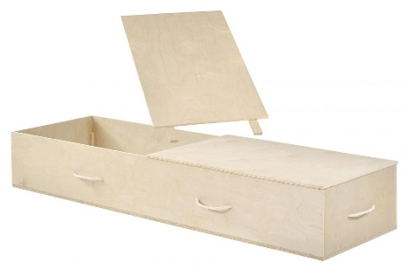 | Victoriaville Glencove  Model # CR8879-00033  Select Wood Construction  White Crepe Interior(if requested)  Natural Maple Woodgram  Rope Carriers | $695.00
3 | 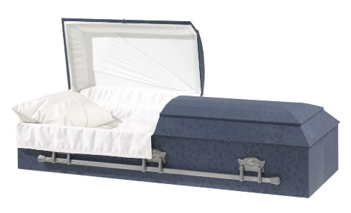 | Victoriaville Winston Cloth  Model # DR220-00044  Blue embossed cloth covered  White silk interior  Metal Swing Handles | $1395.00
4 | 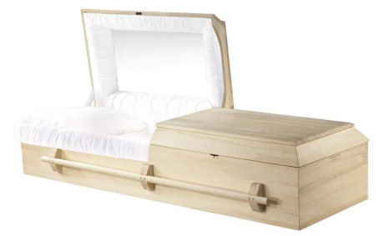 | Victoriaville Diamond Poplar  Model # CR250-00001  Solid Poplar construction  Natural finish  White crepe interior | $1650.00
5 | 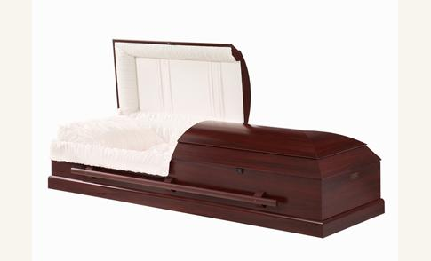 | Victoriaville Gatewood  Model # WR252-00237  Solid Poplar and veneer components Titan colour treatment  White crepe interior  Fixed wooden bar handle | $2295.00
6
 | 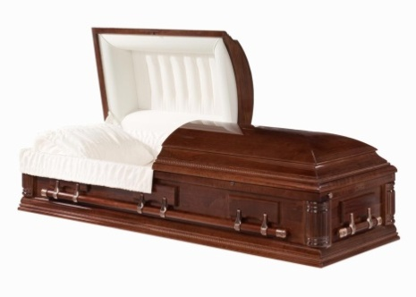 | RENTAL CASKET  Victoriaville Bristol Poplar.  Model # WR252-00322  Solid Poplar Construction  Beige Crepe Interior  Finished in Mid Walnut Stain  High Polish Finish  FINAL CREMATION CONTAINER IS REQUIRED  CASKET PREVIOUSLY USED AND WILL BE USED AFTER | $1695.00 includes  cremation Container

Table of Urns

# | PHOTO | Name, Model and Materials Used | PRICE
1 | 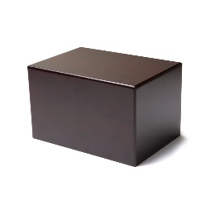 | Butterworth Cherry Laminate Urn  #1510  Cherry Laminate Finish | $295.00
2 | 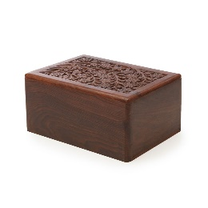 | Butterworth Tun Wood Carved Urn  #6210  Carved Wood Finish | $295.00
3 | 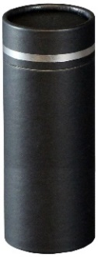 | Victoriaville Silver Lining Scattering Tube  Model # US830-30032  Black Cardboard with Silver Lining Detail | $150.00
4 | 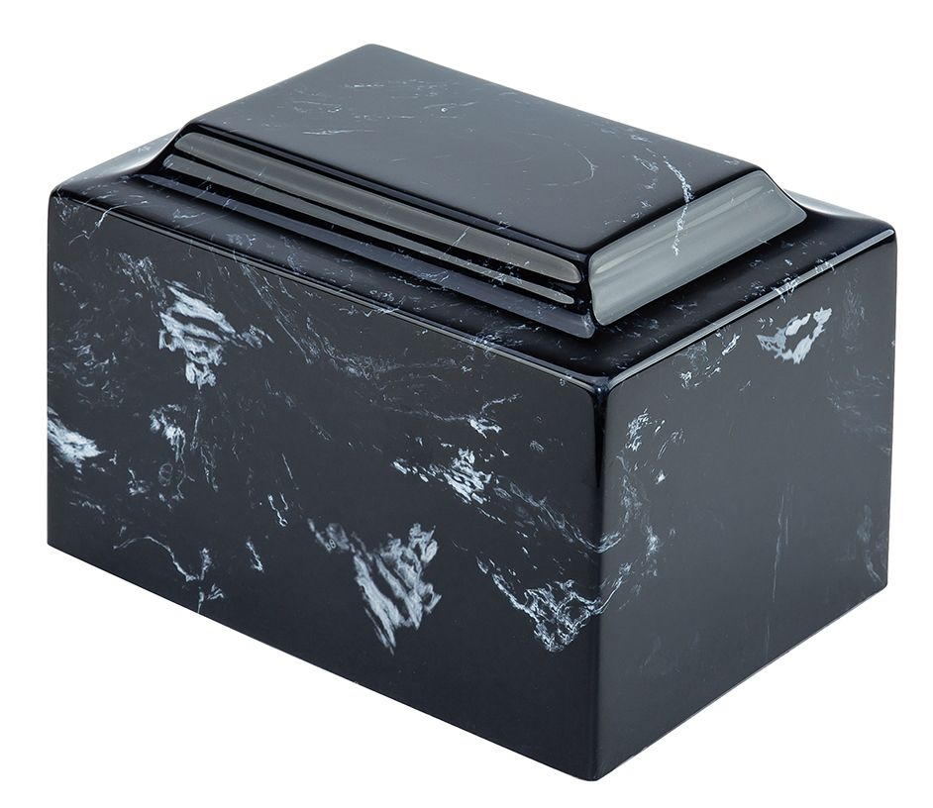 | Victoriaville Marble Ebonytone/Black  Cultured Marble Urn  Victoriaville: US335-20002  Also comes in Evergreen, Coffeetone, Greytone & Rosetone | $395.00
5 | 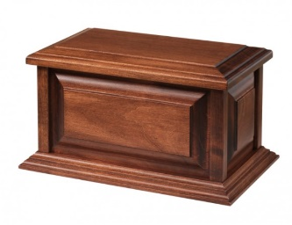 | Victoriaville Allen Urn  US 120-00003  Solid Maple Wood | $395.00
6 | 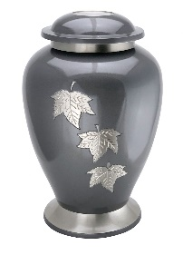 | Victoriaville Falling Leaf Urn  Model # US210-30070  Metal with Nickel Finish | $395.00
7 | 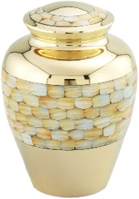 | Victoriaville Mother of Pearl Urn  Model # US210-30065  White Metal | $395.00
8 | 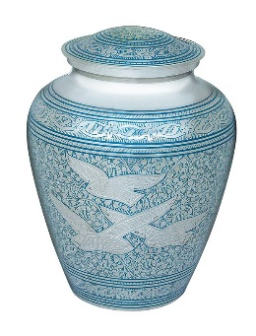 | Victoriaville Going Home Urn  Model # US210-00017  Metal with decorative finish | $395.00
9 | 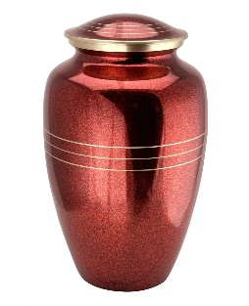 | Victoriaville Classic Red Urn  Model # US210-30043  Red Metal | $395.00
10 | 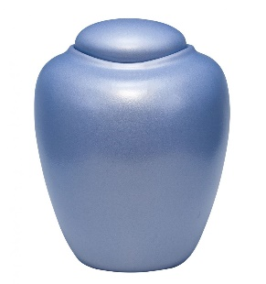 | Victoriaville Gelatin Biodegradable Urn  Model # US899-30117  Ocean Aqua- sustainable materials  Biodegrades in 3 months in water or ground. Environmentally friendly alternative | $395.00

Keepsake Urns

1 | 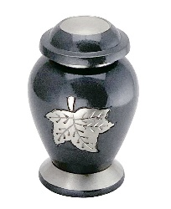 | Victoriaville Eternal Falling Leaf Keepsake  Model # UK210-30107  Keepsake (Mini)  Metal with Nickel Finish | $150.00
2 | 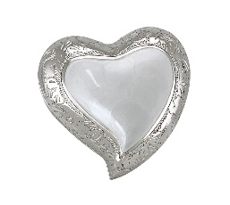 | Victoriaville Elegant Pearl White Heart Keepsake  Model # UK210-30033  Keepsake (Mini)  Metal with decorative finish | $150.00
3 | 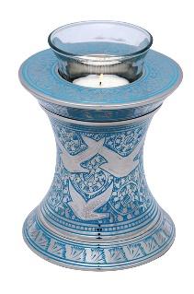 | Victoriaville Going Home Candle Keepsake  Model # UK840-30030  Keepsake (Mini)  Metal with decorative finish | $150.00
4 | 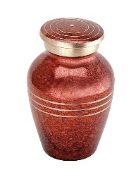 | Victoriaville Classic Red Keepsake  Model # UK210-30027  Keepsake (Mini)  Red Metal | $150.00

Jewellery

# | PHOTO | Name, Model and Materials Used | PRICE
1 | 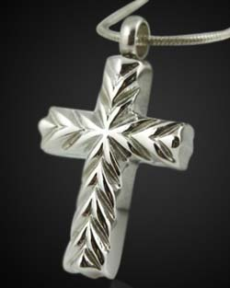 | Victoriaville Necklace  Model # J1900-30113  Cross Stainless Steel | $150.00
2 | 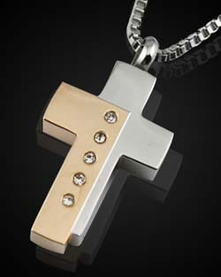 | Victoriaville Necklace  Model # J1900-30104-CC  Two Tone Cross Stainless Steel | $150.00
3 | 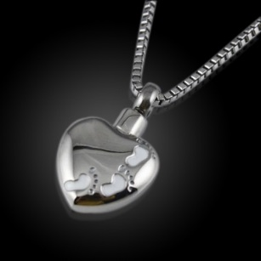 | Victoriaville Necklace  Model # J1900-30122-CC  Footprints/Heart Stainless Steel | $150.00
4 | 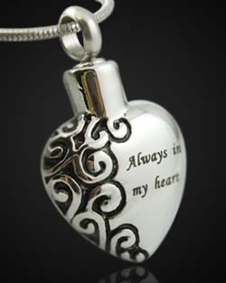 | Victoriaville Necklace  Model # J1900-30103-CC  Always in my Heart Stainless Steel | $150.00
5 | 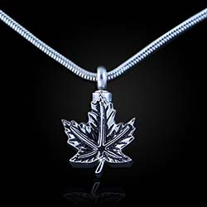 | Victoriaville Necklace  Model # J1900-30141-CC  Maple Leaf Stainless Steel | $150.00
6 | 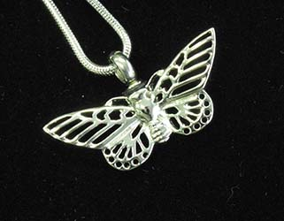 | Victoriaville Necklace  Model # J1900-30130  Butterfly Stainless Steel | $150.00

# | PHOTO | Name, Model and Materials Used | PRICE
7 | 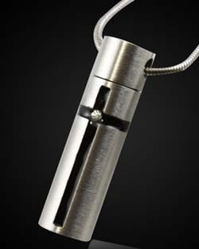 | Victoriaville Necklace  Model # J1900-30102  Cylinder Stainless Steel | $150.00
8 | 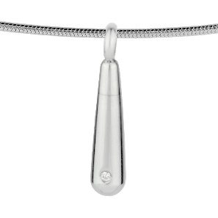 | Victoriaville Necklace  Model # J1900- 30110  Tear Drop Stainless Steel | $150.00
9 | 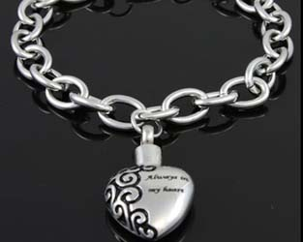 | Victoriaville Bracelet  Model # J1900-30204  Always in my Heart Stainless Steel | $150.00
10 | 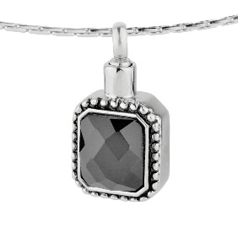 | Victoriaville Necklace  Model # J1900-30112  Square Gem Stainless Steel | $150.00
11 | 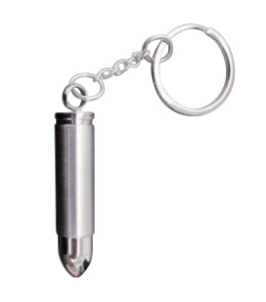 | Victoriaville Keychain  Model # J1900-30310  Bullet Keychain Stainless Steel | $150.00

